You use a lambda expression to create an anonymous function. Use the lambda declaration operator => to separate the lambda's parameter list from its body.
To create a lambda expression, you specify input parameters (if any) on the left side of the lambda operator and an expression or a statement block on the other side.
Any lambda expression can be converted to a delegate type. The delegate type to which a lambda expression can be converted is defined by the types of its parameters and return value. If a lambda expression doesn't return a value, it can be converted to one of the Action delegate types; otherwise,

it can be converted to one of the Func delegate types. For example, a lambda expression that has two parameters and returns no value can be converted to an Action<T1,T2> delegate. A lambda expression that has one parameter and returns a value can be converted to a Func<T,TResult> delegate.
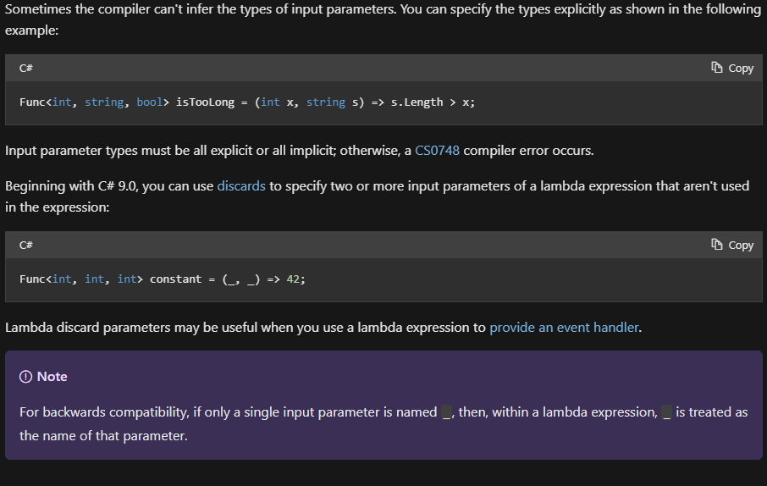
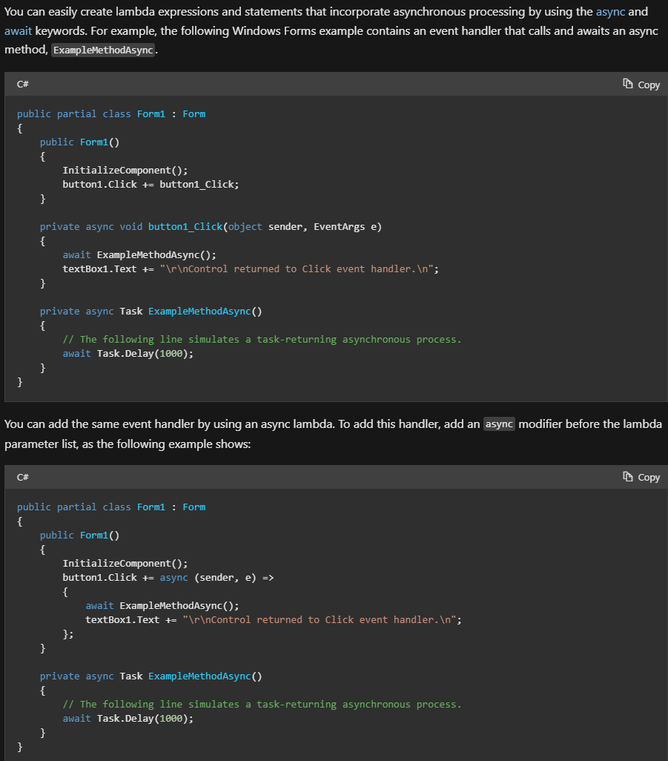
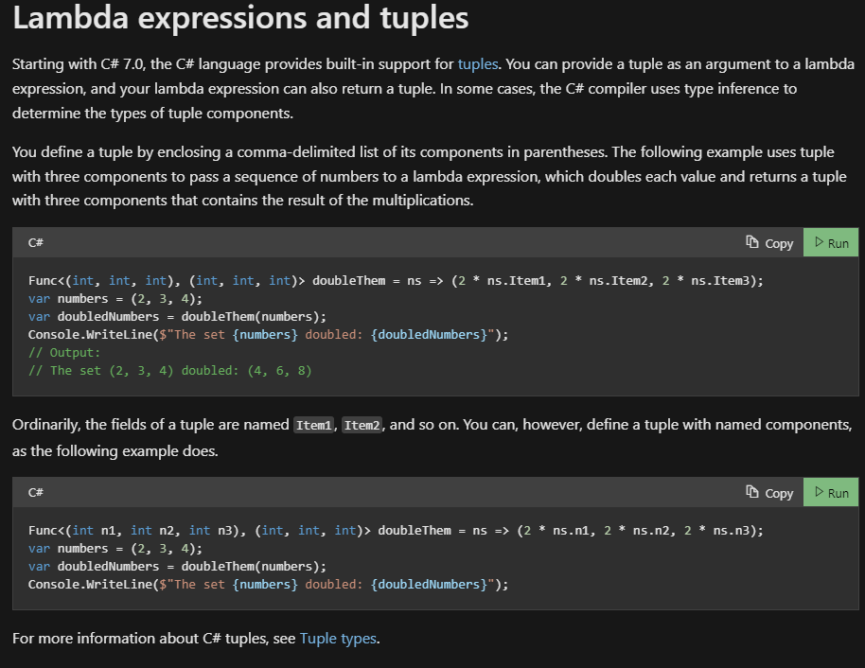

Func<int, bool> equalsFive = x => x == 5;
bool result = equalsFive(4);
Console.WriteLine(result); // False

int[] numbers = { 5, 4, 1, 3, 9, 8, 6, 7, 2, 0 };
int oddNumbers = numbers.Count(n => n % 2 == 1);
Console.WriteLine($"There are {oddNumbers} odd numbers in {string.Join(" ", numbers)}");

int[] numbers = { 5, 4, 1, 3, 9, 8, 6, 7, 2, 0 };
var firstNumbersLessThanSix = numbers.TakeWhile(n => n < 6);
Console.WriteLine(string.Join(" ", firstNumbersLessThanSix));
// Output:
// 5 4 1 3

int[] numbers = { 5, 4, 1, 3, 9, 8, 6, 7, 2, 0 };
var firstSmallNumbers = numbers.TakeWhile((n, index) => n >= index);
Console.WriteLine(string.Join(" ", firstSmallNumbers));
// Output:
// 5 4

You don't use lambda expressions directly in query expressions, but you can use them in method calls within query expressions, as the following example shows:
var numberSets = new List<int[]>
{
new[] { 1, 2, 3, 4, 5 },
new[] { 0, 0, 0 },
new[] { 9, 8 },
new[] { 1, 0, 1, 0, 1, 0, 1, 0 }
};

var setsWithManyPositives =
from numberSet in numberSets
where numberSet.Count(n => n > 0) > 3
select numberSet;

foreach (var numberSet in setsWithManyPositives)
{
Console.WriteLine(string.Join(" ", numberSet));
}
// Output:
// 1 2 3 4 5
// 1 0 1 0 1 0 1 0

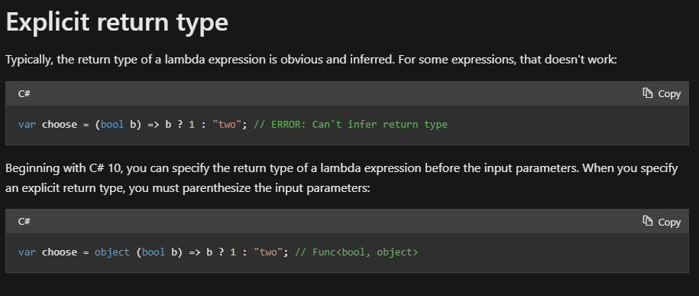
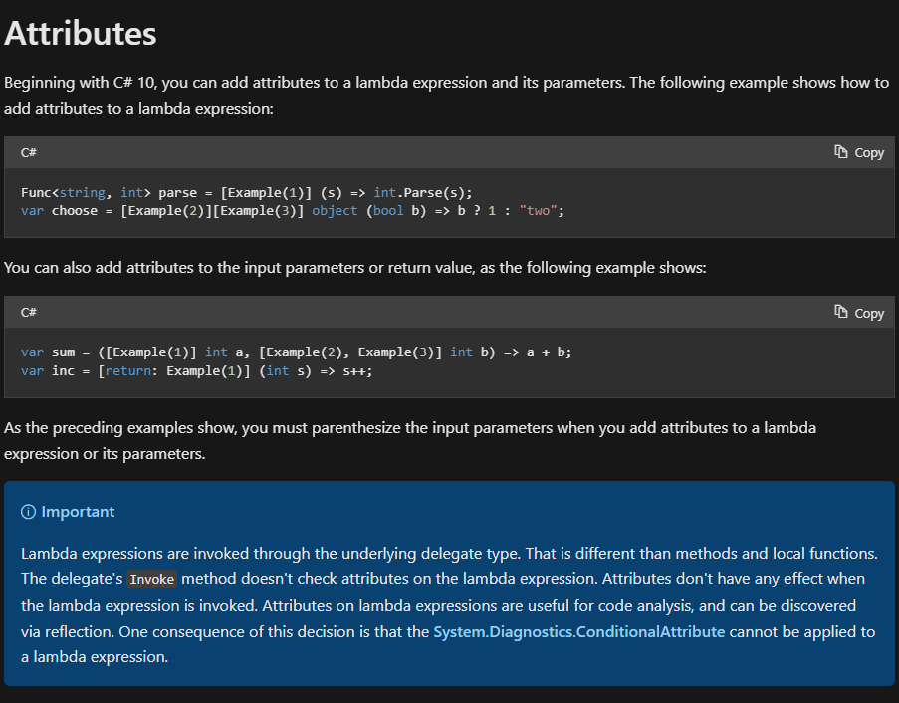
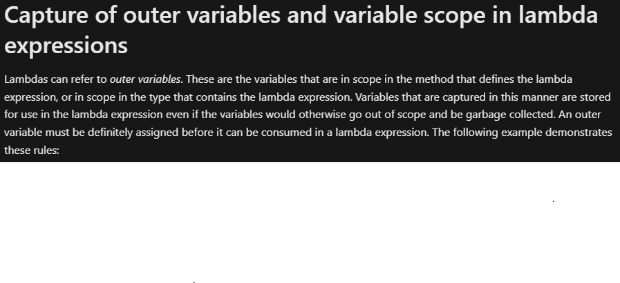
public static class VariableScopeWithLambdas
{
public class VariableCaptureGame
{
internal Action<int>? updateCapturedLocalVariable;
internal Func<int, bool>? isEqualToCapturedLocalVariable;

public void Run(int input)
{
int j = 0;

updateCapturedLocalVariable = x =>
{
j = x;
bool result = j > input;
Console.WriteLine($"{j} is greater than {input}: {result}");
};

isEqualToCapturedLocalVariable = x => x == j;

Console.WriteLine($"Local variable before lambda invocation: {j}");
updateCapturedLocalVariable(10);
Console.WriteLine($"Local variable after lambda invocation: {j}");
}
}

public static void Main()
{
var game = new VariableCaptureGame();

int gameInput = 5;
game.Run(gameInput);

int jTry = 10;
bool result = game.isEqualToCapturedLocalVariable!(jTry);
Console.WriteLine($"Captured local variable is equal to {jTry}: {result}");

int anotherJ = 3;
game.updateCapturedLocalVariable!(anotherJ);

bool equalToAnother = game.isEqualToCapturedLocalVariable(anotherJ);
Console.WriteLine($"Another lambda observes a new value of captured variable: {equalToAnother}");
}
// Output:
// Local variable before lambda invocation: 0
// 10 is greater than 5: True
// Local variable after lambda invocation: 10
// Captured local variable is equal to 10: True
// 3 is greater than 5: False
// Another lambda observes a new value of captured variable: True
}

